Window Functions
______________________________________________________________________________
Dataset: HR database - employees table
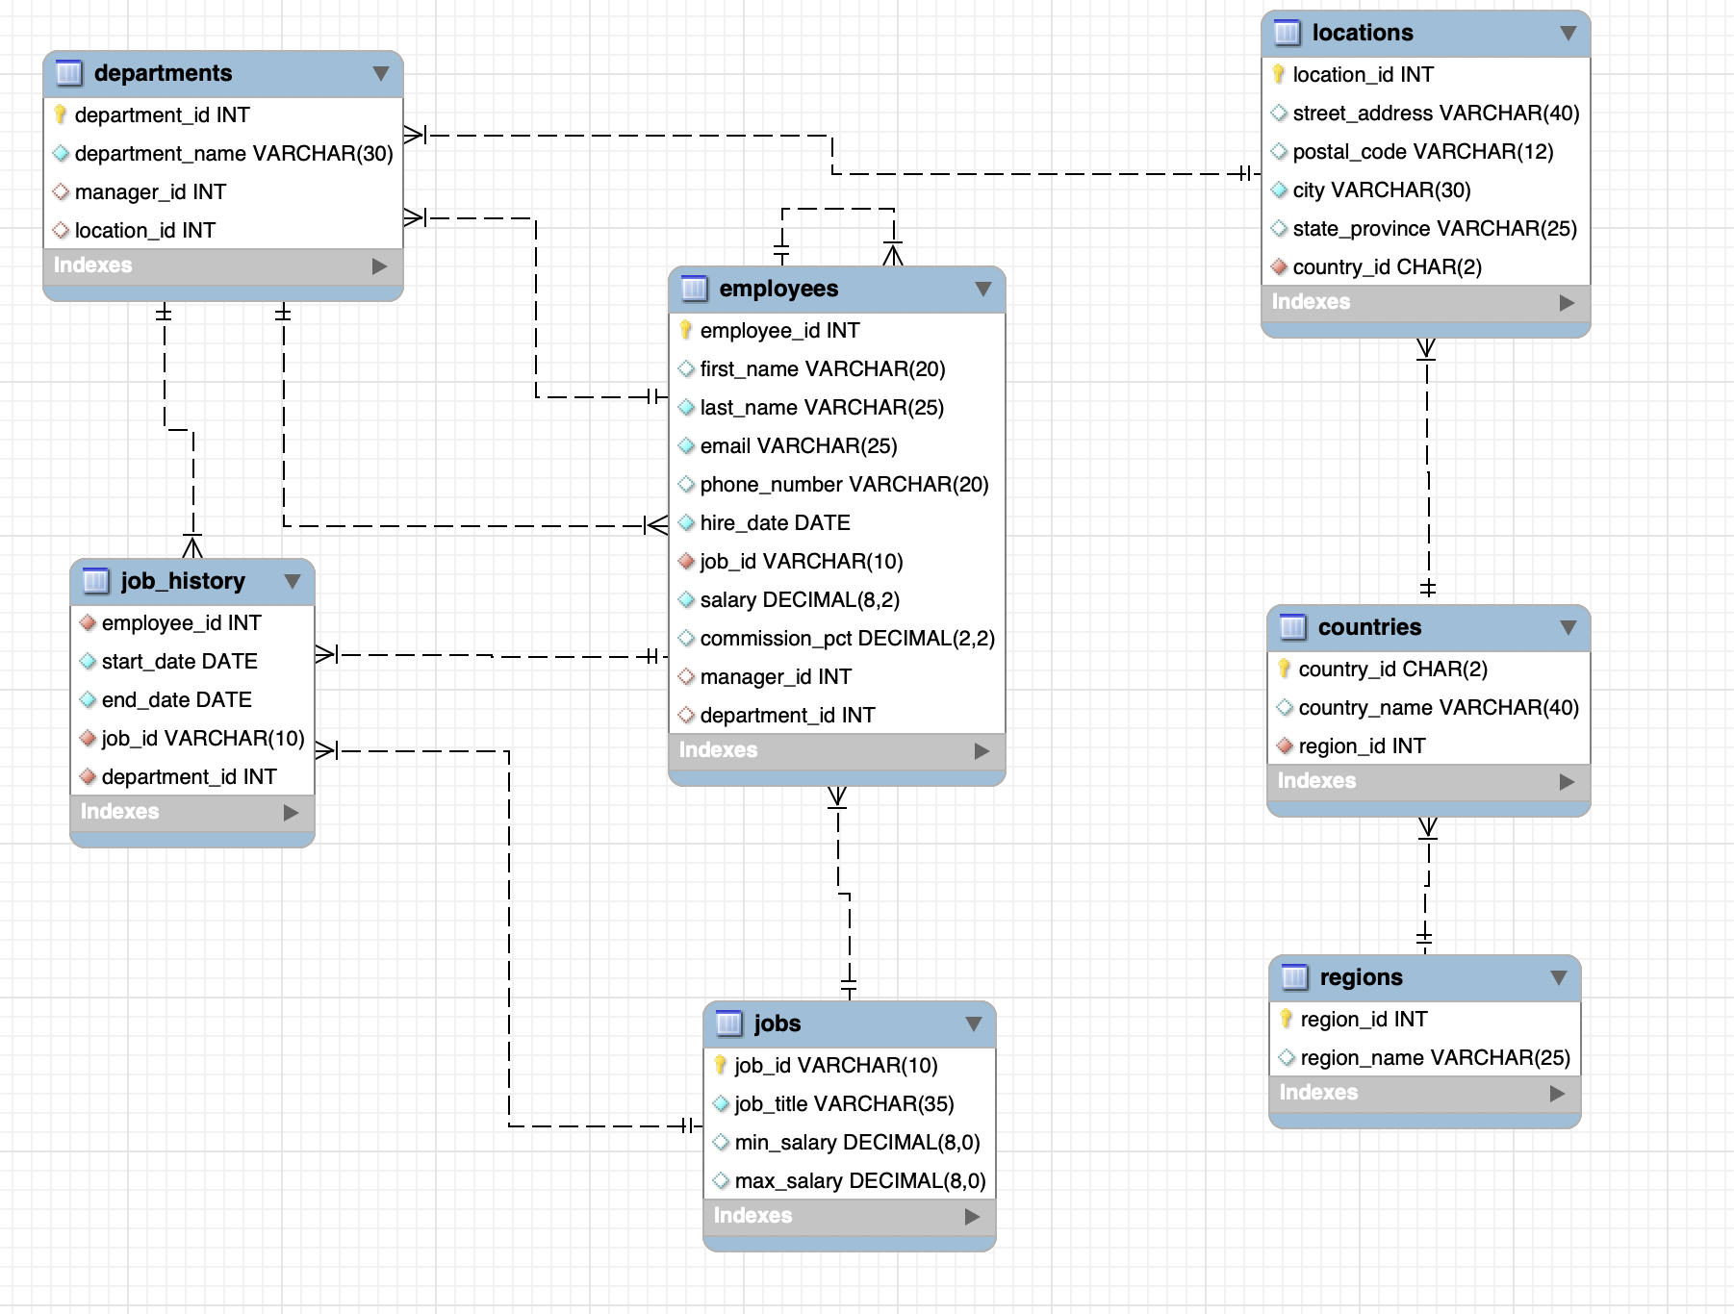
____________________________________________________________________________

#Q: Find the employees having salaries greater than the average salary of all the employees.

We can easily solve this using a Subquery.

Query:
SELECT *
FROM employees
WHERE salary >
( SELECT
AVG(salary)
FROM employees )

#Q: Find the employees having salaries greater than the average salary of all employees in their respective department.

To do this comparison we need an adjacent column `avg_sal` in our table.

What does Group By do to the output? - Groups / Collapses rows.

- All the functions covered, like ROUND(), return one value in each row of the results dataset.
- When GROUP BY is used, the functions operate on multiple values in an aggregated group of records, summarizing across multiple rows in the underlying dataset, like AVG(), but each value returned is associated with a single row in the results.
- The output is always grouped.

One way to solve this would be -
If you apply a grouping operation to derive a new table, you will obtain a result set with department IDs and their corresponding average salaries.
Now, all that remains is to join both tables on the department_id.

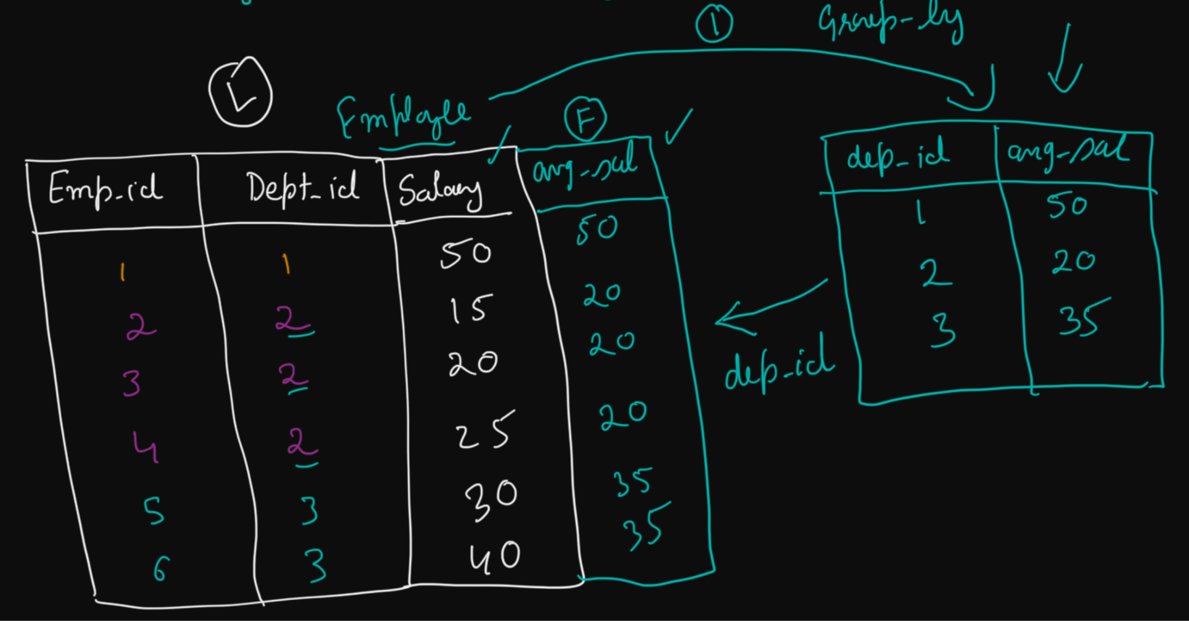

Query:
SELECT
employee_id,
first_name, last_name,
e.department_id,
salary, avg_sal
FROM (
SELECT
department_id,
ROUND(AVG(salary)) AS avg_sal
FROM hr.employees
GROUP BY department_id) d
JOIN hr.employees e
ON d.department_id = e.department_id;
______________________________________________________________________________

Transitioning -> What if we want to operate on multiple rows but don’t want the records to be grouped in the output?

Window Functions
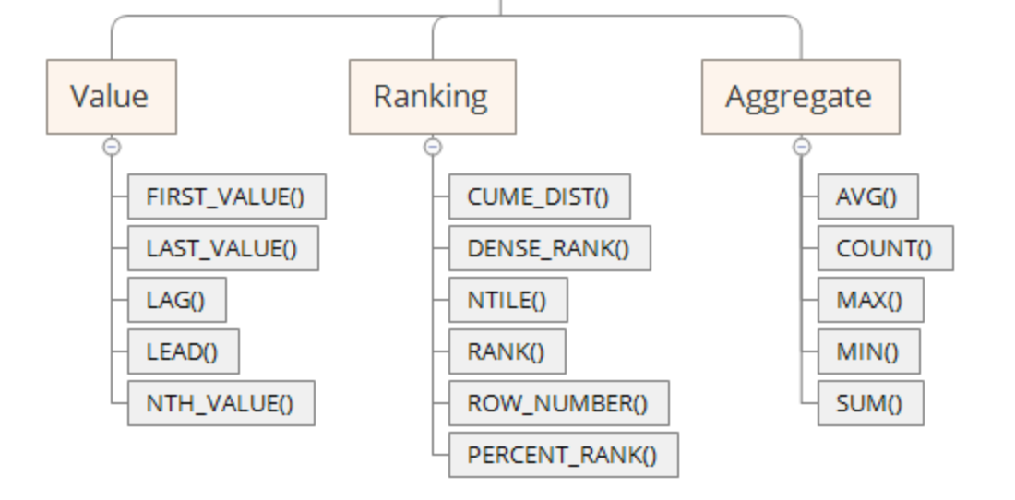

Window function gives the ability to put the values from one row of data into context compared to a group of rows or partitions.

It's important to note that CUME_DIST() and PERCENT_RANK() will not be part of our curriculum as they are beyond the current scope.

We can answer questions like:
- Where would this row land in the results if the dataset were sorted? - Rank
- How does a value in this row compare to the prior row? - Accessing the preceding / following row.
- How does a current row value compare to the group or partition(in window function’s context) average value?

So, window functions return group aggregate calculations alongside individual row-level information for items in that group or partition.
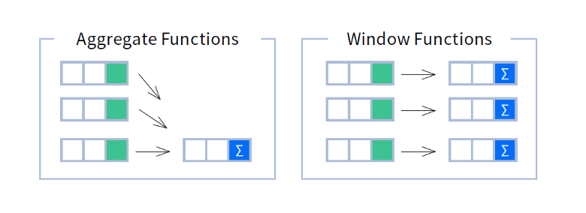
Syntax:
SELECT
window_function_name (expression)
OVER (
[PARTITION BY partition_expression, ... ]
ORDER BY sort_expression [ASC | DESC], …
) AS col_alias
FROM [table_name]

- OVER() - It tells the DBMS to apply the function over a window of rows.
- PARTITION BY - This clause divides the result set into partitions or groups based on the specified columns.
- ORDER BY - This clause orders the rows within each partition based on the specified columns and their sort order.
______________________________________________________________________________

Aggregated Window Functions

#Q: Display the average salary of all employees in a new column from the employees table.

Here, we do not want to lose the original data, but we want a new column with the aggregated data.

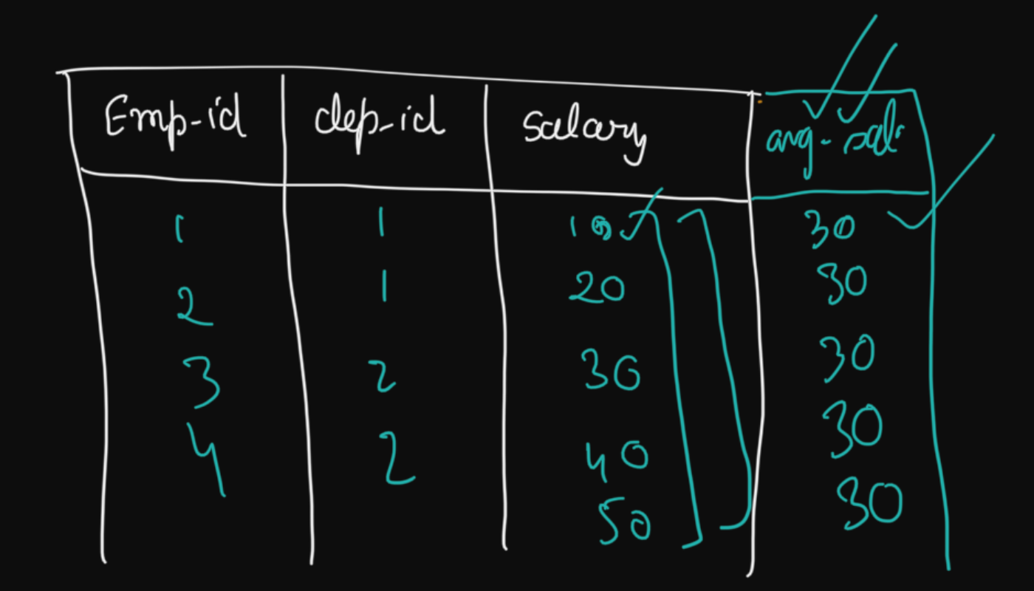

Query:
SELECT
employee_id,
department_id,
salary,
AVG(salary) OVER() AS avg_salary
FROM hr.employee;

#Q: How can we present the average salary of employees in each department by adding a new column adjacent to the respective employees within their corresponding departments?

Query:
SELECT
employee_id,
department_id,
salary,
AVG(salary) OVER(PARTITION BY department_id) AS avg_salary
FROM hr.employee;
______________________________________________________________________________

Let’s answer the questions that we discussed in the beginning of this session -

#Q: Display the details of employees having salaries greater than the average salary of all the employees.

Query:
SELECT *
FROM
(SELECT
employee_id,
department_id,
salary,
AVG(salary) OVER() AS avg_salary
FROM hr.employee) as tbl
WHERE salary > avg_salary;

#Q: Display the details of employees having salaries greater than the average salary of all employees in their respective department.

Query:
SELECT *
FROM
(SELECT
employee_id,
department_id,
salary,
ROUND(AVG(salary) OVER(PARTITION BY department_id)) AS avg_salary
FROM hr.employee) tbl
WHERE salary > avg_salary;
______________________________________________________________________________

ROW_NUMBER

#Q: Find the top 5 earning employees in the company.

You might have solved such questions earlier using ORDER BY and LIMIT clauses.

But what if 2 employees have the exact same salaries?
In that case, we need to come up with a way to rank the data.

We need a function that allows us to rank rows by a value - ROW_NUMBER().

Syntax : ROW_NUMBER() OVER (<partition_definition> <order_definition>)

Here, the highest salary will get row number 1 and so on…

Query:
SELECT
employee_id,
department_id,
salary,
ROW_NUMBER() OVER(ORDER BY salary DESC) AS row_num
FROM hr.employee
WHERE
row_num <= 5;
______________________________________________________________________________

Transitioning ->
The problem with the output in ROW_NUMBER() is that even for the same values, we are getting different numbers or ranks but what if you want the same rank to be assigned to the same values.

RANK and DENSE_RANK

Continuing with the same question...

To return the top 5 earning employees when there is more than one employee having the same salary, we use the RANK function.

The RANK function numbers the results just like ROW_NUMBER does, but assigns the same ranking to rows with identical values.

There’s another function called DENSE_RANK which although similar but is slightly different from RANK. While both functions provide rankings for result sets, DENSE_RANK does not leave gaps in ranking.

We'll understand the difference between these 3 functions using the illustration given below.

Illustration ->

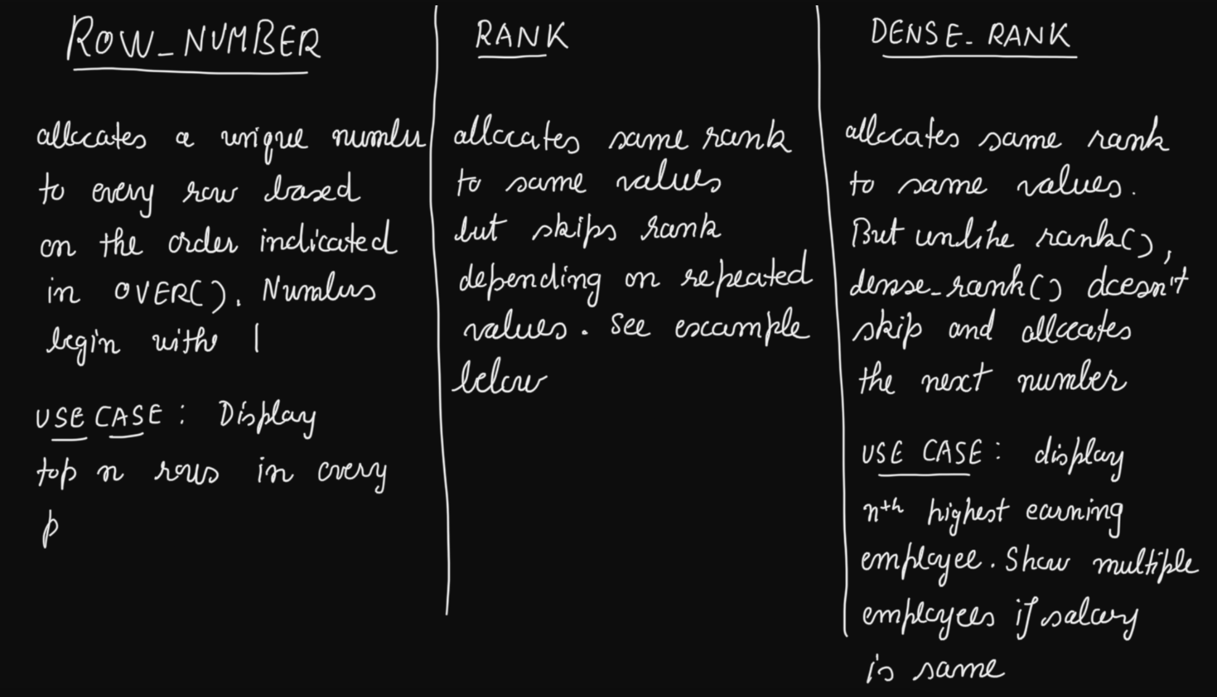
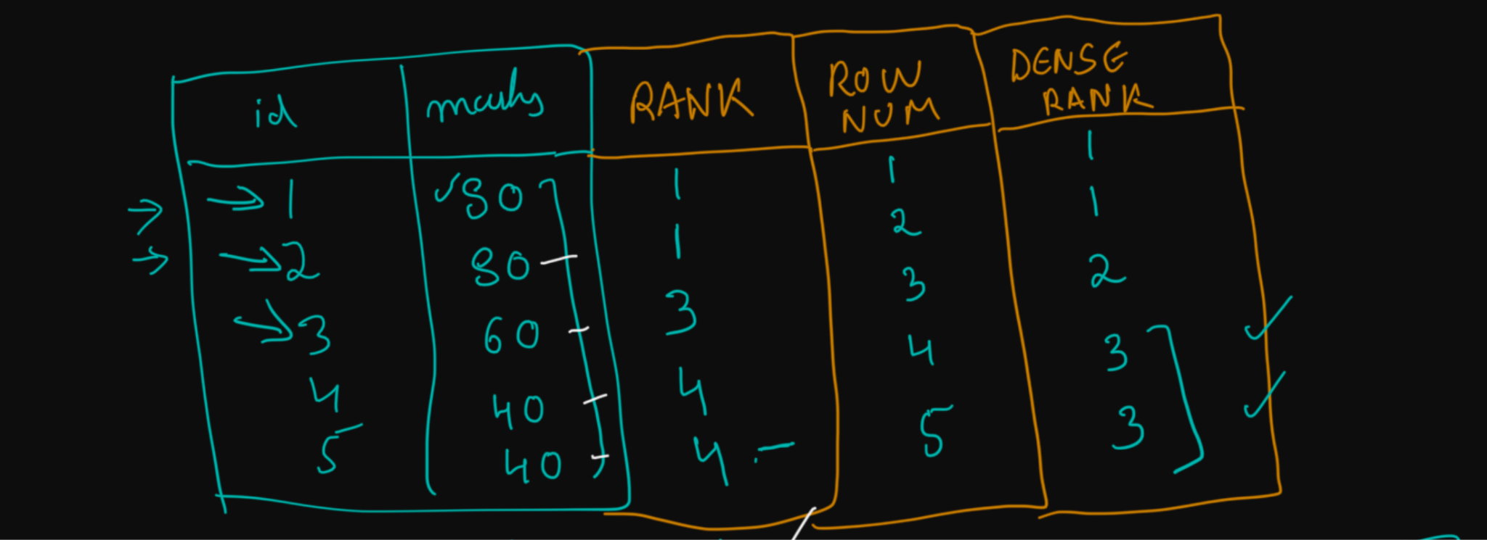______________________________________________________________________________

Replacing ROW_NUMBER with RANK/DENSE_RANK in the original query -

Query:
SELECT
employee_id,
department_id,
salary,
ROW_NUMBER() OVER(ORDER BY salary DESC) AS row_num,
RANK() OVER(ORDER BY salary DESC) AS sal_rank,
DENSE_RANK() OVER(ORDER BY salary DESC) AS sal_dense_rank
FROM hr.employee
ORDER BY
sal_rank,
sal_dense_rank,
row_num;

#Q: Fetch the details of employees with the highest salaries from each department.

Query:
SELECT *
FROM
(SELECT
employee_id,
department_id,
salary,
ROW_NUMBER() OVER(PARTITION BY department_id ORDER BY salary DESC) AS row_num,
RANK() OVER(PARTITION BY department_id ORDER BY salary DESC) AS rank,
DENSE_RANK() OVER(PARTITION BY department_id ORDER BY salary DESC) AS dense_rank,
FROM hr.employee) tbl;
______________________________________________________________________________

Homework -

#Q: From each department, display the details of the employee having maximum salary. Display multiple people if they have the same salaries.

#Q: From each department, display the details of the employee having the 3rd highest salary. Display multiple people if they have the same salaries.
______________________________________________________________________________

NTILE

Imagine you have a group of people, and you want to divide them into smaller groups, but you want each group to have about the same number of people.

NTILE() helps you do that by splitting them into a specified number of approximately equal-sized groups or buckets.

For each row in a group, the NTILE() window function assigns a bucket number representing the group to which the row belongs.

Syntax:
NTILE(num_buckets) OVER (PARTITION BY partition_column ORDER BY order_column)

What are Quartile, Quintile, and Decile?
- Quartiles divide a data set into 4 equal parts.
- Quintiles divide a data set into 5 equal parts.
- Deciles divide a data set into 10 equal parts.

#Q: Divide all the employees into 4 different buckets (i.e. quartiles) based on their salaries.
- The 1st quartile should contain the employees with the lowest salaries.
- The 4th quartile should contain the employees with the highest salaries.

Query:
SELECT
employee_id,
department_id,
salary,
NTILE(4) OVER(ORDER BY salary) AS sal_group
FROM hr.employee
ORDER BY sal_group;

Important points about NTILE()
- If the number of rows in the results set can be divided evenly, the results will be broken up into n equal sized groups, labeled 1 to n.
- If they can’t be divided up evenly, some groups will end up with one more row than others.
- The ORDER BY salary clause within the NTILE() function ensures that the rows are ordered by salary before they are divided into groups.
- Note that the NTILE() is only using the count of rows to split the groups, and is not using a field value to determine where to make the splits.
- Therefore, it’s possible that two rows with the same value specified in the ORDER BY clause will end up in two different groups.
______________________________________________________________________________

